FS80 + Ultra Light Bracket

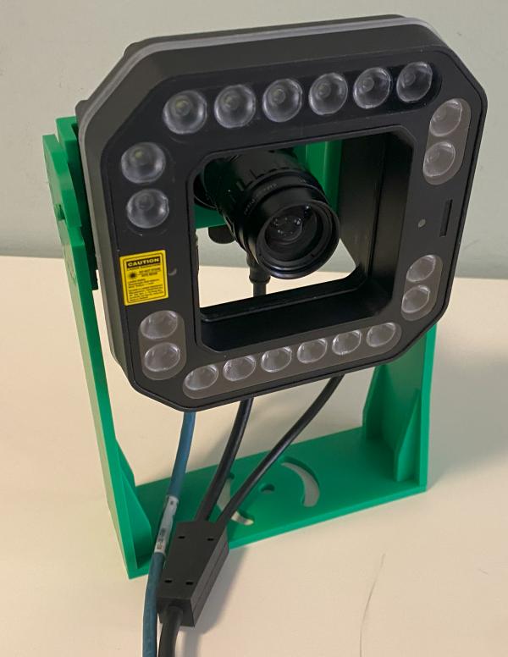

Table of Contents
Project goals 3
FS80+UL Bracket 4
FS80+UL Pivot Base 5
Mounting holes 6
Base rotation 6
Reinforcement holes 6
Shoulders 7
Design 7
Shoulder Base 7
Ribs and mounting holes 7
FS80 + UL Pivot Shoulder Right 8
FS80 + UL Pivot Shoulder Left 9
Final result 10
For Next Iteration 11
Reference 12

Project goals
Create a support bracket for Zebra FS80 and Ultra Light illuminator that can be easy to mount and easy to use in lab.
Key point are:
- Lens are adjustable without removing from the camera
- The camera can be removed without changing the system orientation
- The bracket can be mounted on a 60 mm Bosch profile
- The mounted camera and illuminator are stable and balanced.
- The height is enough to let the cable pass through without excessive stress or forced bend.
- Camera and illuminator are fixed using just one set of screws: M4x10 Cylindrical Hex Screws.

Version 2.0
- Improve the base bracket to handle correctly the 90x45 mm Bosch Profile
- Make a few slots that can accept T Bolts

https://amzn.eu/d/byO3eKk

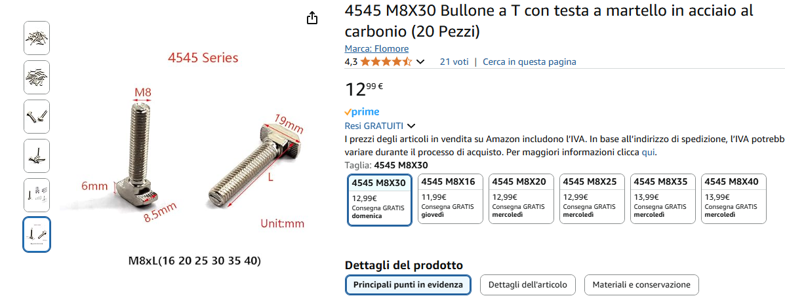

FS80+UL Bracket
I use multiple bends to gain enough space for the lens. The goal is to have the lens aligned with the LED protection. This to make possible the implementation of a polarized cover for both LED and Lens.
The position of the rotating pins has been calculated to provide a good balancing of the camera.

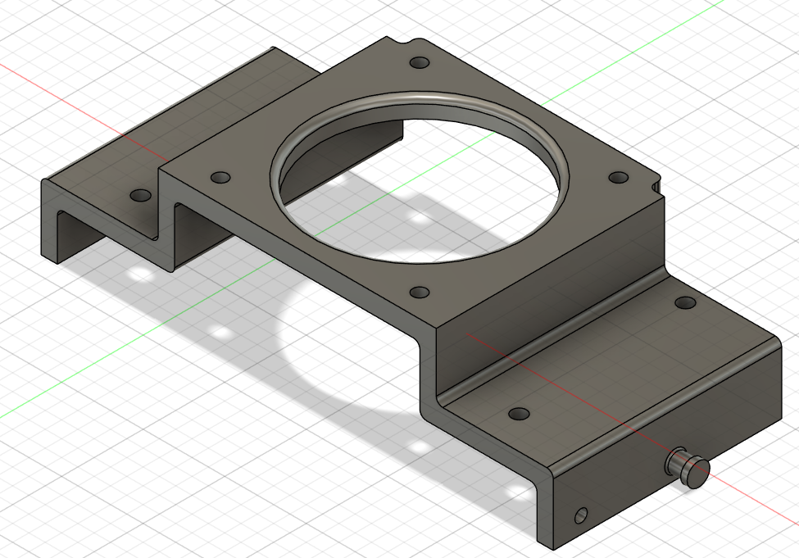

FS80+UL Pivot Base
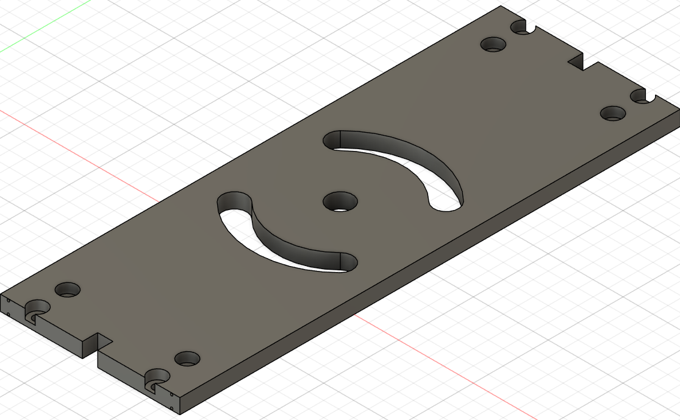

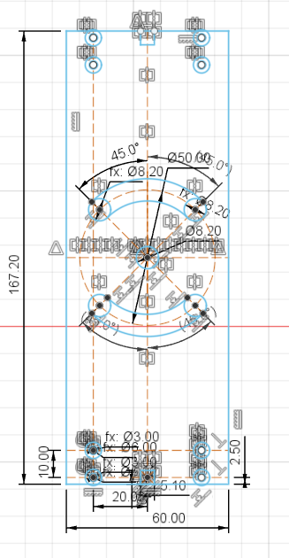

Mounting holes
The base is assembled with the shoulder using 4 screws (4x M3x16) and a small slot in the center.
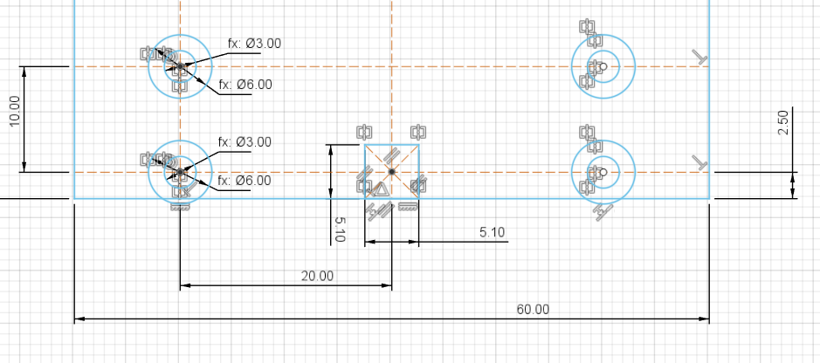

Base rotation
The central hole and the 2 side slots allows for 90 degrees rotation (+/- 45 Deg)

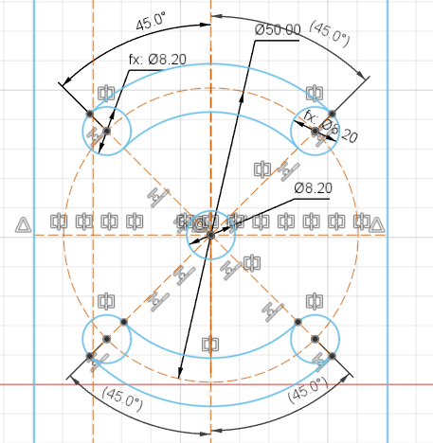

Reinforcement holes
I created 4 holes in the base to force the slicer to add more material and make it more rigid.
The Holes are 0.8 mm and close to the top and bottom face to maximize the resistance.

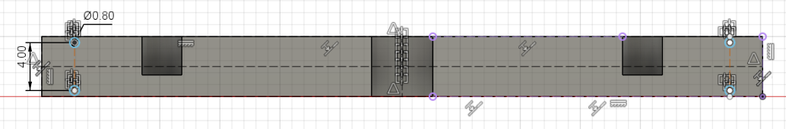

Shoulders

Design

Shoulder Base
I add 5 mm each side to reach 60 mm width. This makes possible to create a more stiff base plate and the dimension is the same as widely used 60 mm Bosch profiles.

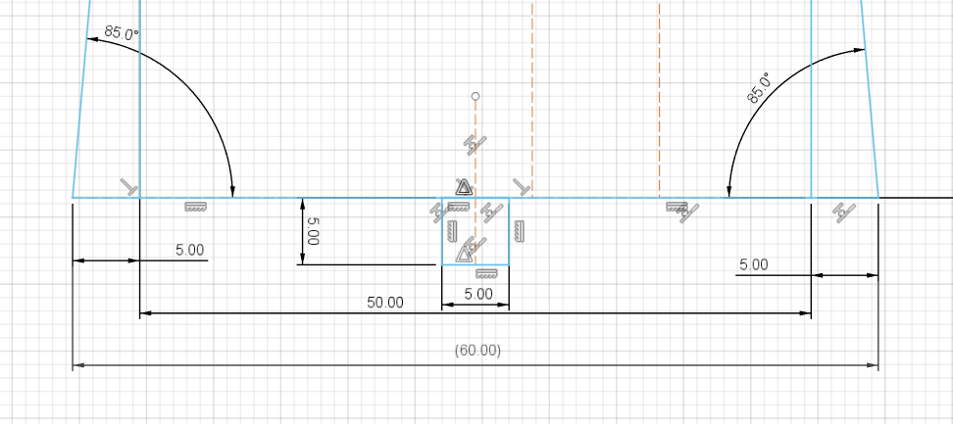

Ribs and mounting holes
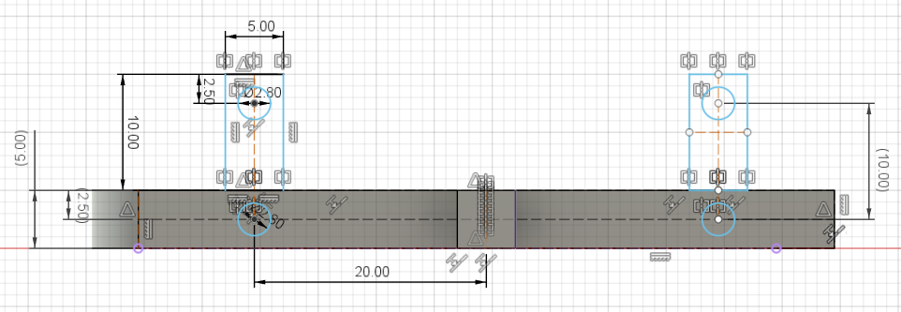

FS80 + UL Pivot Shoulder Right
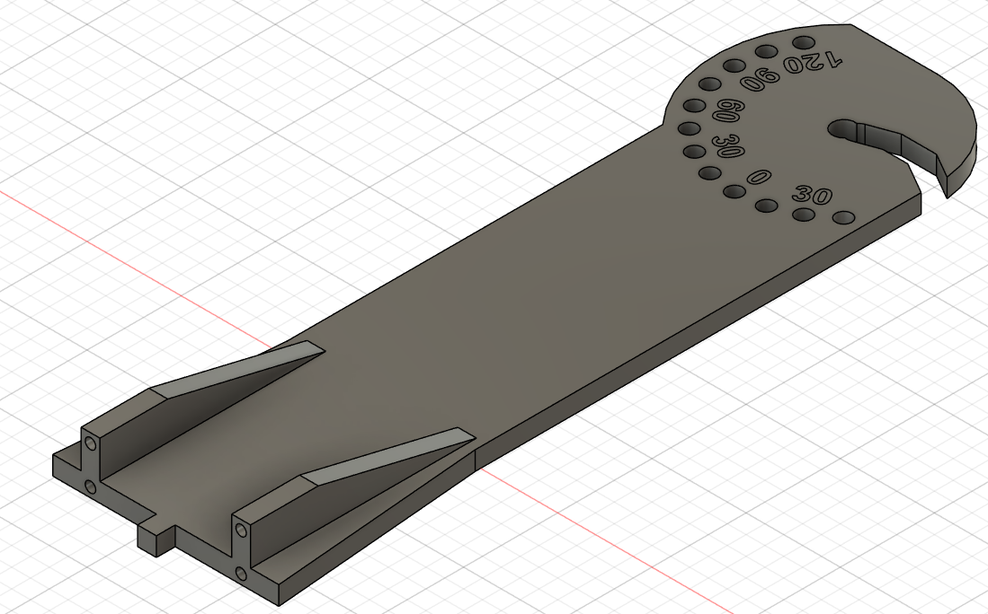

FS80 + UL Pivot Shoulder Left

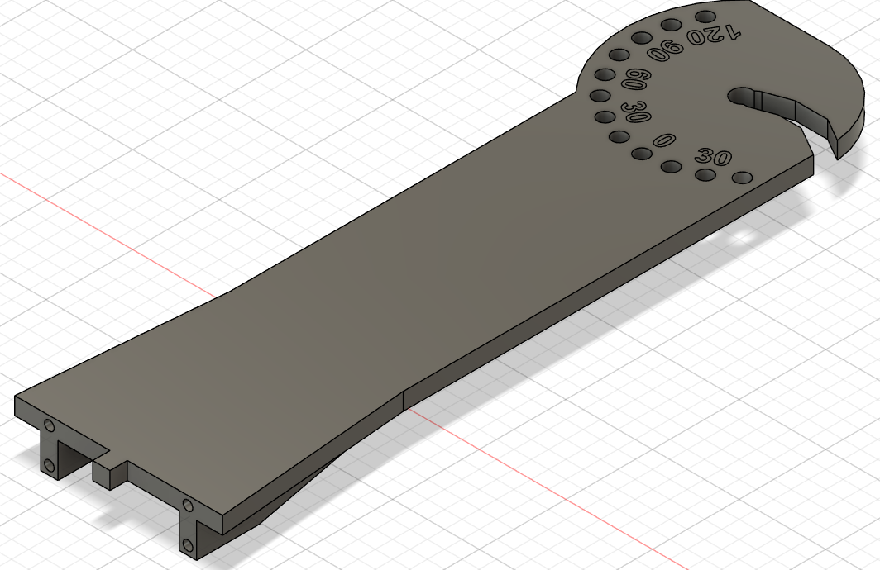

Final result
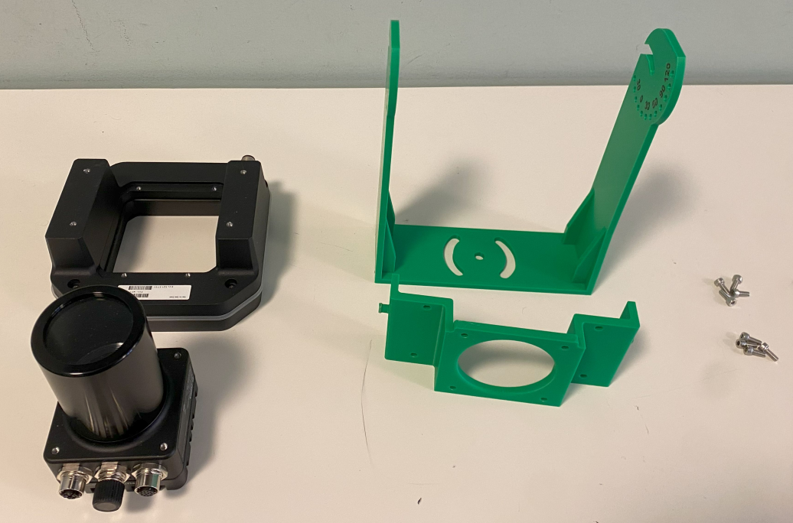

For Next Iteration
To be more error proof a small extrusion should be add to identify the correct bracket orientation.
This should be on the top side of the bracket so if we try to mount it upside down we can’t because of the connectors.
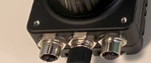 | 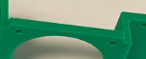

Reference
This is an example of Bosch profile with a 60 mm width.

https://store.boschrexroth.com/Tecnica-di-montaggio/Elementi-meccanici-di-base/Profilati-e-accessori/Profilo?cclcl=it_IT

